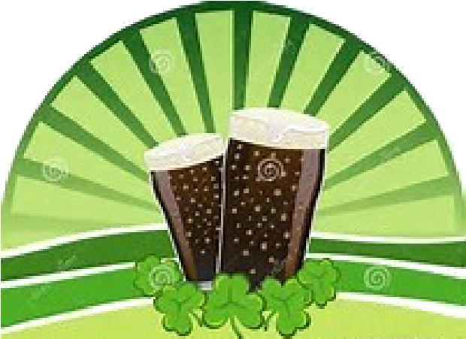
ST. PATRICK’S DAY SPECIALS
Corned Beef & Cabbage $18  Tender Corned Beef & Steamed Cabbage w/  Béchamel Sauce & Red Potatoes  Hot Irish Stew $18  Hearty Beef Stew w/ Potatoes & Carrots  Served w/ French Roll & Butter  Irish Nachos $15  Steak Fries, Seasoned Ground Beef, Cheddar Cheese, Sour Cream and Pico De Gallo  Lucky Baldwins’  Fish & Chips $16  Icelandic Cod Dipped in Ale Batter, Deep Fried to Perfection. Served w/ Fries & Tartar Sauce  Bangers & Mash $18  Pork Bangers w/ Mashed Potatoes, Peas & Gravy  Cottage Pie $18  Spiced Ground Angus Beef w/ Mashed Potatoes.  LB Burger $16  Classic Cheese Burger Served on Brioche Bun w/ Your Choice of Fries or Seasoned Crisps | Beer Specials  Festive beers on Tap from $9!  Guinness Irish Stout  Harp Irish Larger  Smithwick's Irish Red Ale  Kilkenny Irish Cream Ale  While Supplies Last!  Beer & Glass for $16  OR  Beer, Glass & Lucky Baldwin's  T-Shirt for $28

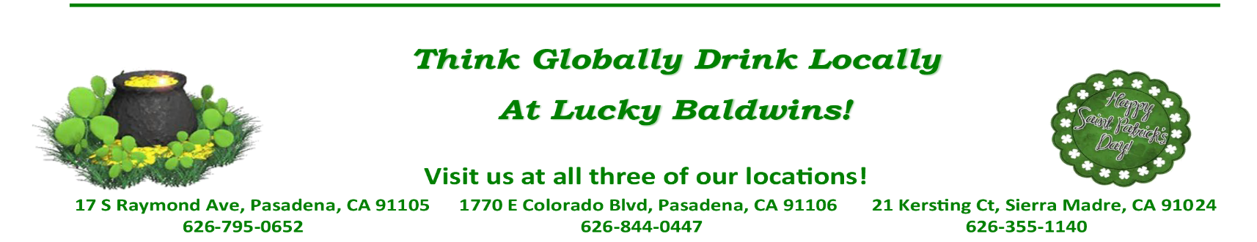
*During these busy times, please no substitutions to the menu items

